**Mainframes DXC Australia**

**Assessment 6: DB2**

**By: Pranay Yara**

**9/08/2024**

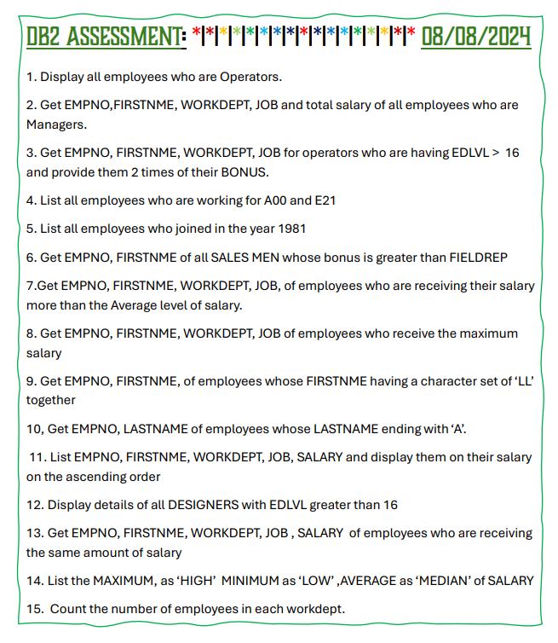

**Table**:

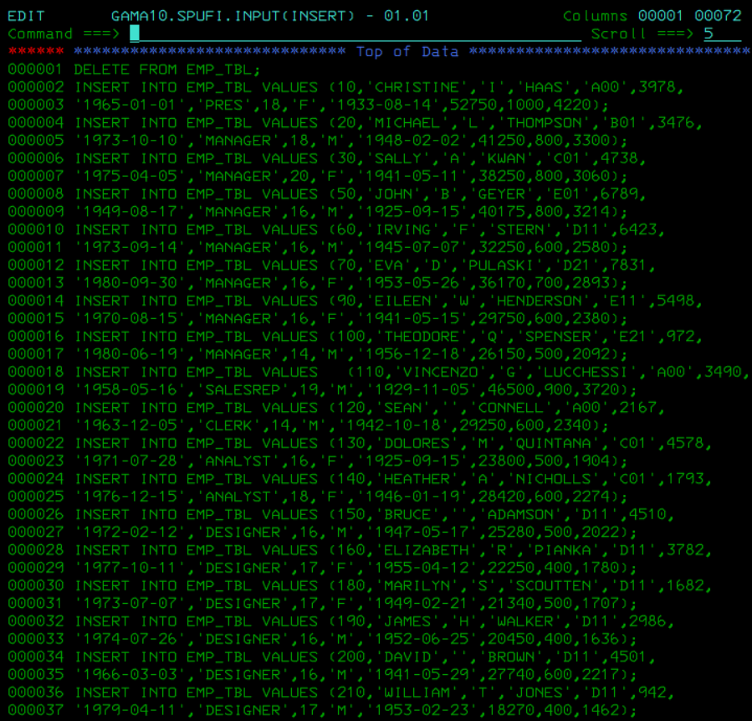

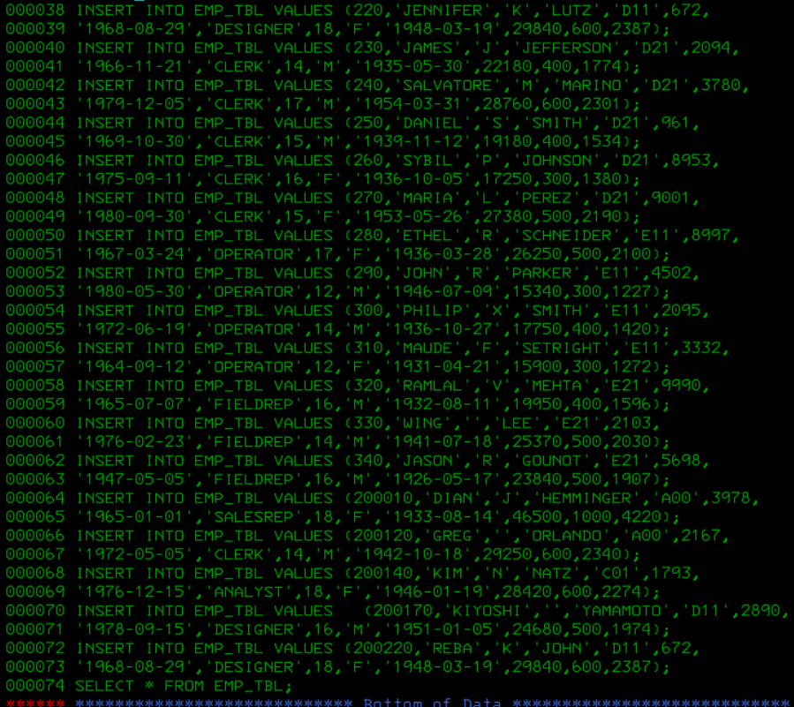

**Output**:

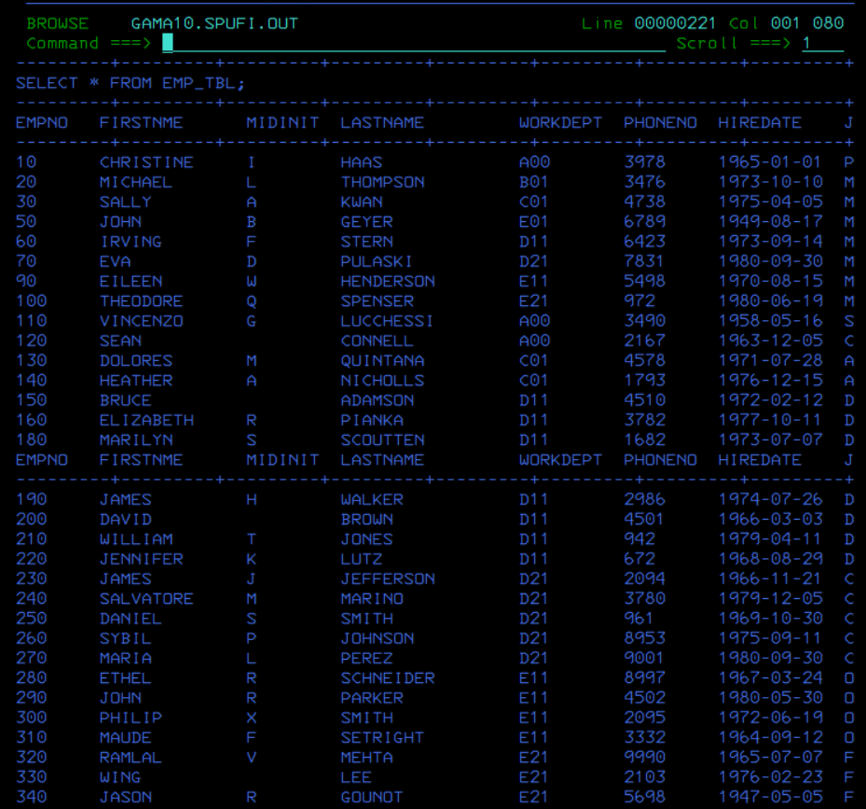

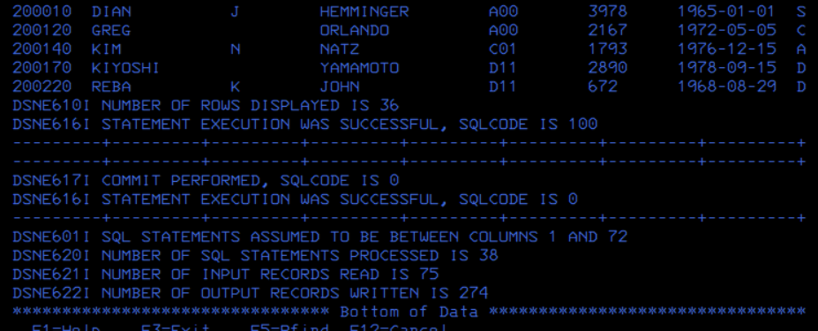

**DB2 ASSESSMENT**

**Comments**: I completed the assessment without any struggle and checked all the outputs with the expected outputs. The formatting of this assessment may seem messy but I only had two hours before my ID was revoked due to the end of the programming application.

**Question 1**:

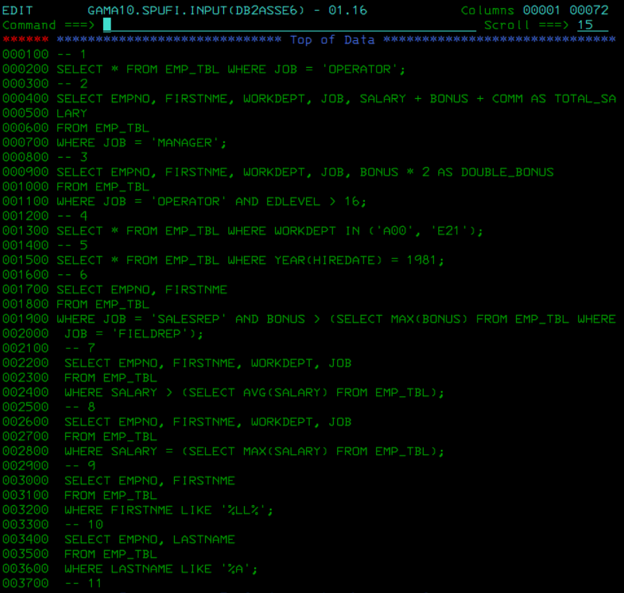

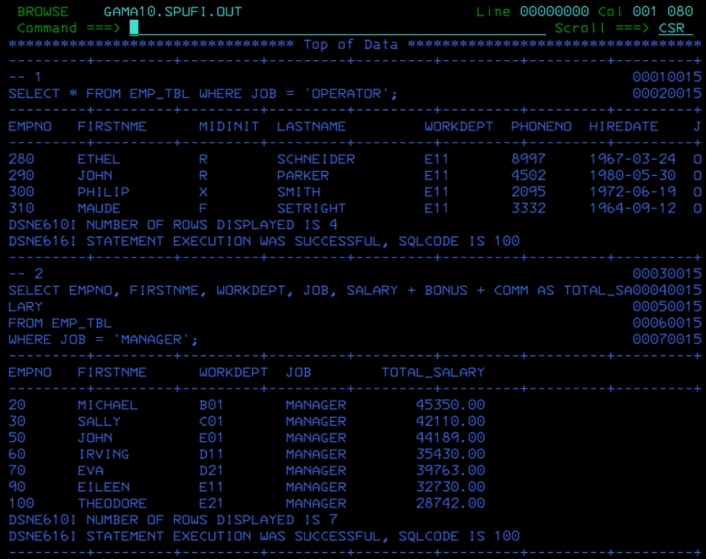

**Question 2**:





**Question 3**:

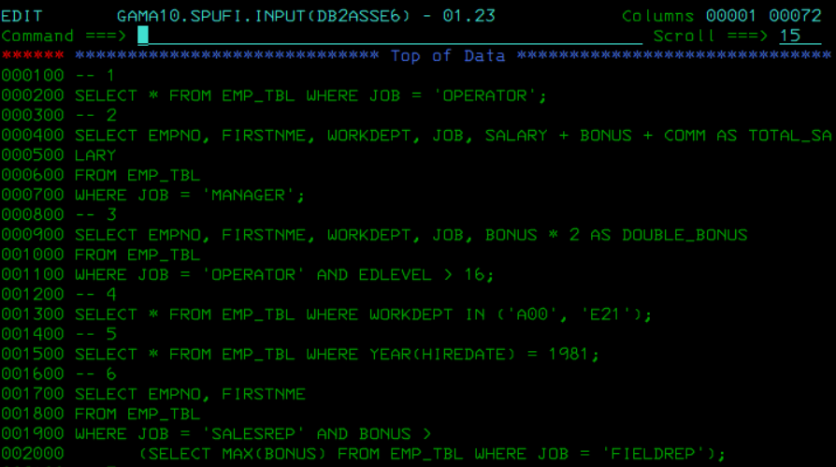

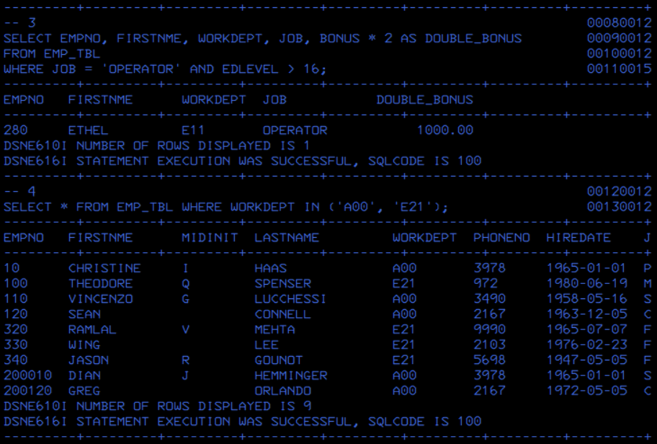

**Question 4**:





**Question 5**:



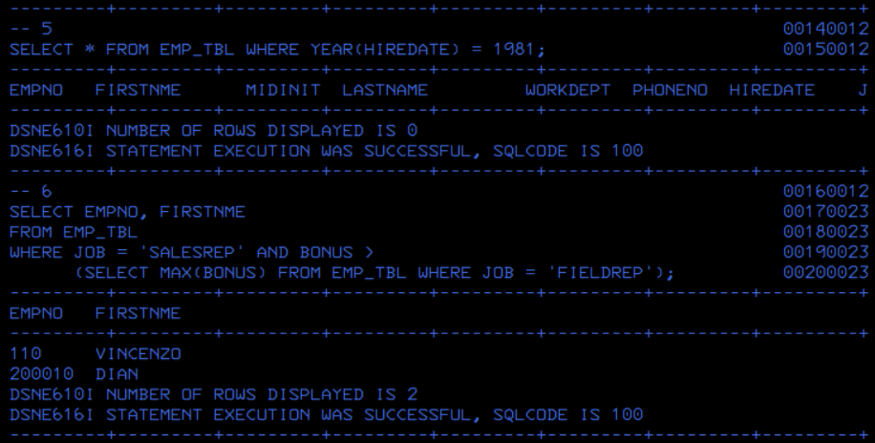

**Question 6**:





**Question 7**:

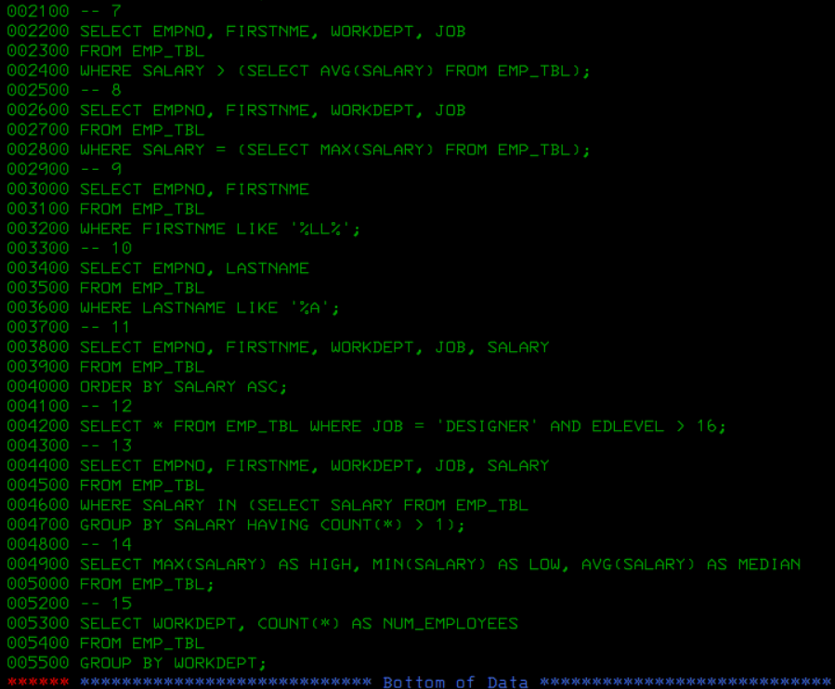

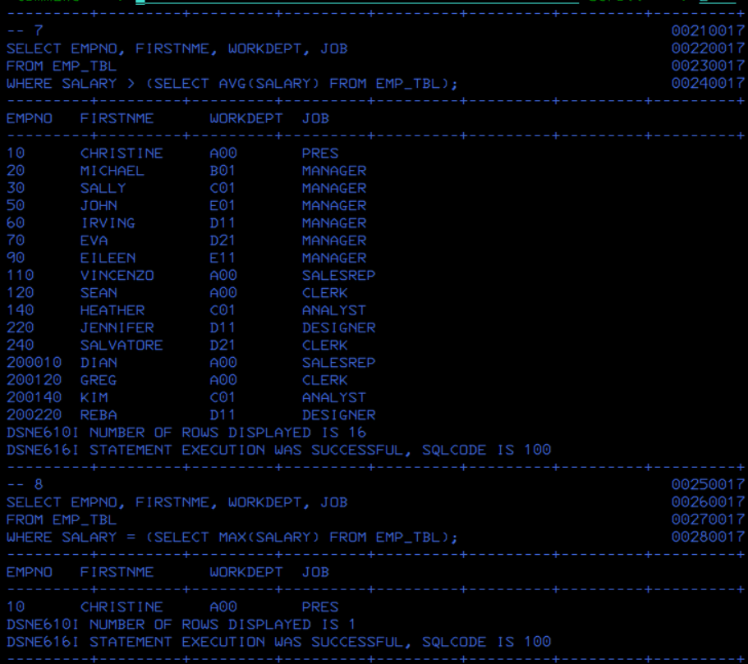

**Question 8**:





**Question 9**:



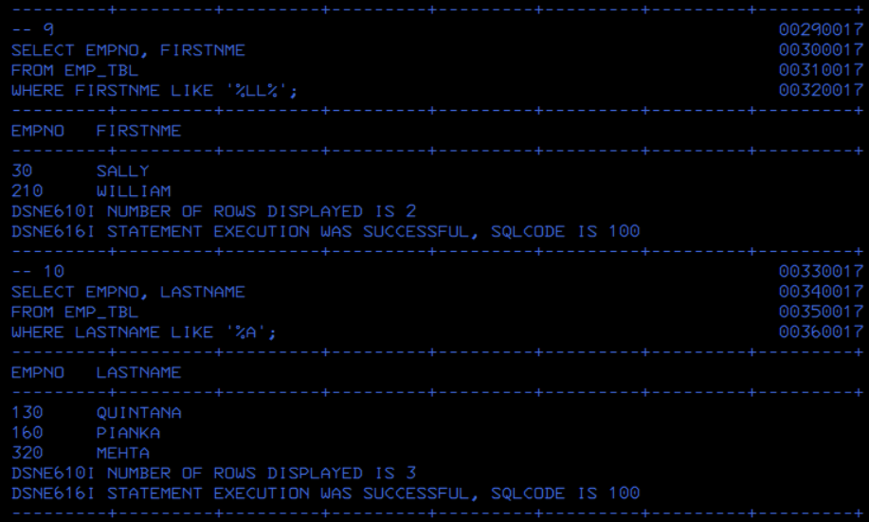

**Question 10**:





**Question 11**:



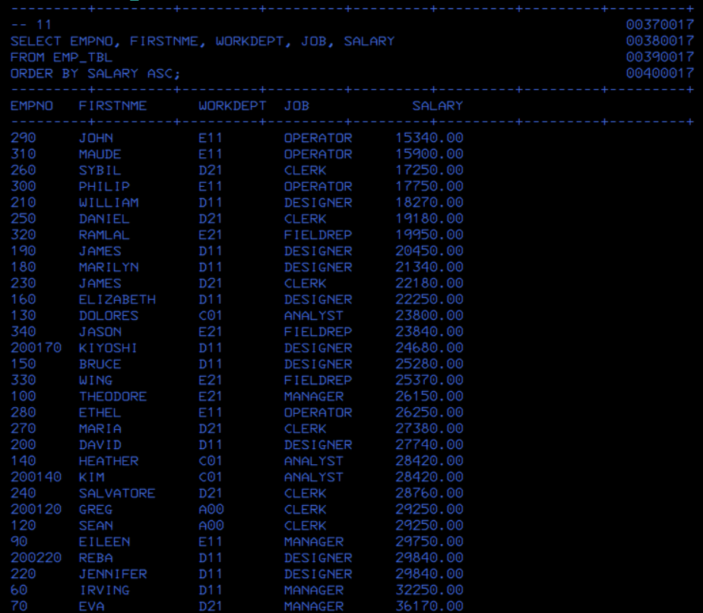

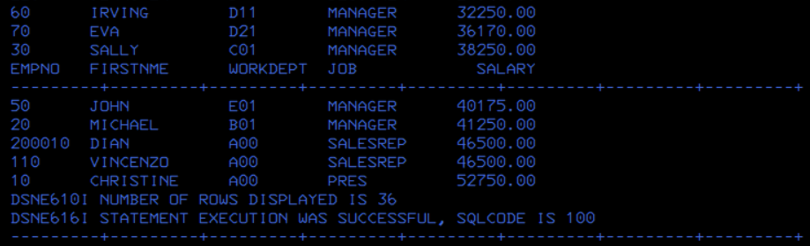

**Question 12**:



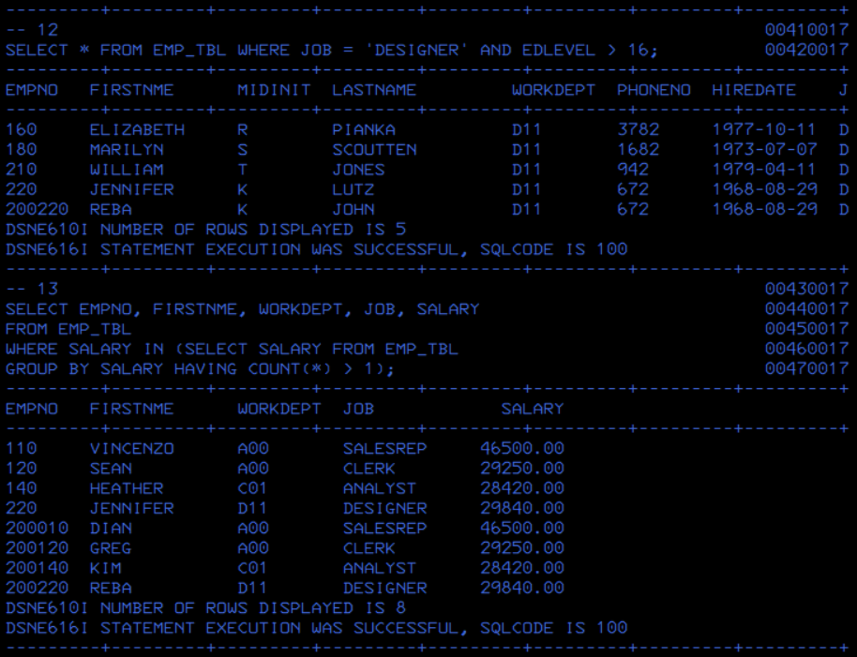

**Question 13**:





**Question 14**:



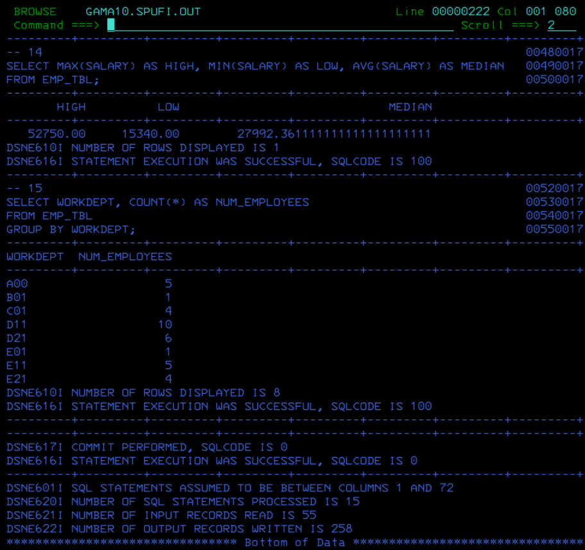

**Question 15**:



